Task 1: Devices Using SMPS and UPS

Devices that use SMPS
No. | Device | Type of Power Supply | Why it uses SMPS
1 | Desktop PC | SMPS | Needs an SMPS to efficiently convert 230V AC into regulated +12V/+5V/+3.3V DC for the CPU, GPU, and drives without wasting energy as heat.
2 | Laptop Charger | SMPS | The charger converts AC mains electricity into suitable DC power for the laptop and battery charging circuit.
3 | LED Monitor | SMPS | Needs efficient low-voltage DC conversion that stays cool during long continuous use, which a bulky linear supply can't do well.

Devices that use UPS
No. | Device | Type of Power Supply | Why it uses UPS
1 | Desktop PC | UPS | A UPS provides temporary battery power during a power cut, allowing the user to save work and shut down the computer safely.
2 | Wi-Fi Router | UPS | A UPS can keep the router operating during a short power interruption, maintaining network/Internet connectivity when the ISP service is still available.

Task 2: Internal Components of a Typical Desktop SMPS

A Switched Mode Power Supply (SMPS) converts AC electricity from the wall outlet into regulated DC voltages required by a computer.
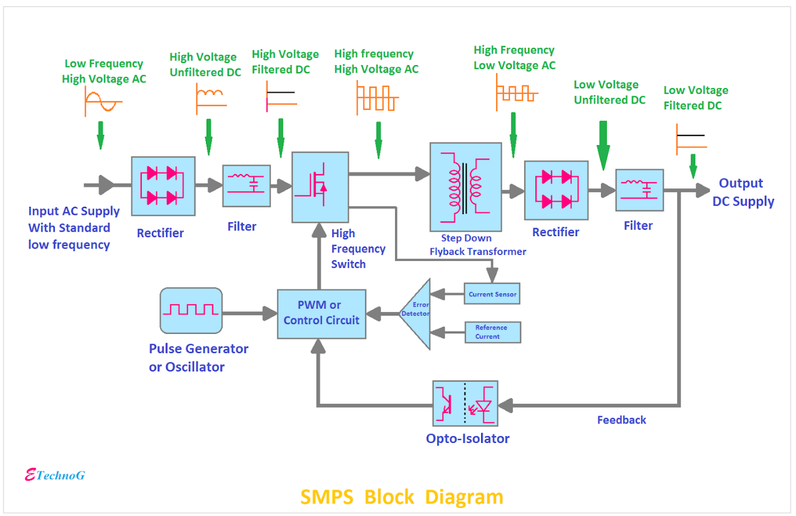
- Rectifier: Converts AC input into unregulated DC voltage.
- Filter: Smooths the rectified DC voltage.
- Inverter/Switching: Converts DC into high-frequency AC using switching devices.
- Transformer: Steps the high-frequency AC up or down to the required voltage level.
- Output Rectifier: Converts the AC output from the transformer back into DC.
- Output Filter: Smooths the DC output and provides stable DC voltage to computer components.
For lower voltage uses silicon/ Schottky diodes used and smoothing the rectified output by using filter
Flow:
AC → Rectifier → Filter → Switching → Transformer → Rectifier → Filter → DC Output

Task 3: PC Power Connectors

- ATX 24-pin Motherboard Connector

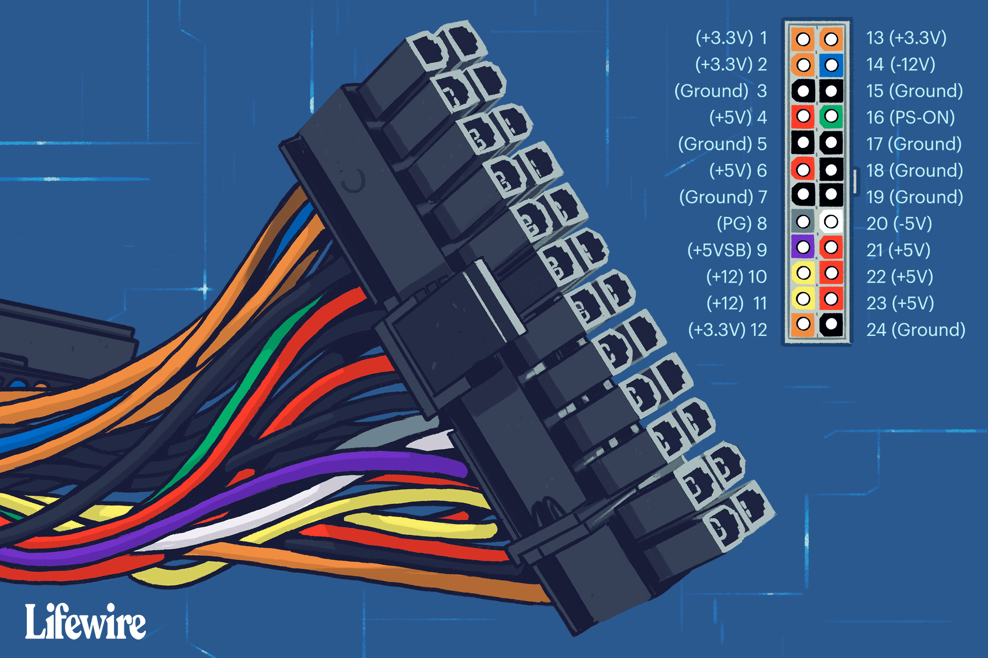
Powers: It supplies the main electrical power to the motherboard.
Used for:
  - Motherboard
  - Chipset
  - RAM and motherboard circuits
  - Other motherboard-connected components
Safety tip:
Make sure the connector is correctly aligned with the keyed socket and press it until the locking clip engages. Never force the connector.

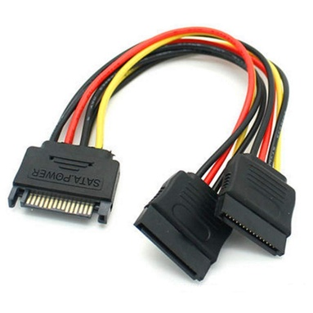
- SATA Power Connector

Powers: It provides power to SATA-based storage and optical devices.
Used for:
  - SATA HDD
  - SATA SSD
  - DVD/Blu-ray optical drives
Safety tip:
Align the L-shaped connector correctly before inserting or removing it. Do not force it at an incorrect angle.

- Molex Connector
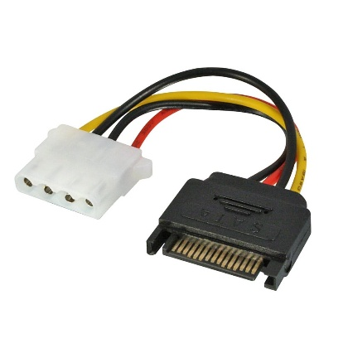
Powers: It was commonly used for older PC components and some accessories.
Used for:
  - Older HDDs
  - Older optical drives
  - Some case fans
  - Older computer accessories
Safety tip:
Turn off and unplug the PC before connecting or disconnecting the Molex connector, and do not force it if the pins are misaligned.

- PCIe 6/8-pin Connector
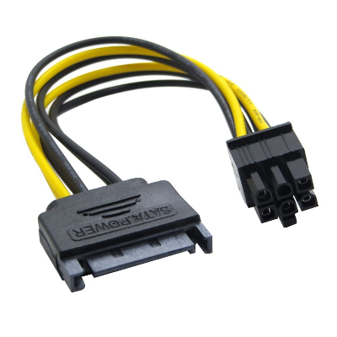
Powers: It provides additional power to a dedicated graphics card.
Used for:
  - Dedicated GPU
  - Some high-power PCIe expansion cards
Safety tip:
Use the PCIe cable supplied by the PSU and ensure it is fully inserted.
Do not confuse a PCIe GPU cable with the CPU/EPS power cable.
Task 4: Connecting the SMPS in a New Gaming PC

Before starting, switch off the PSU, unplug the AC power cable, and make sure the PC is not connected to electrical power.

Step 1: Install the SMPS

- Place the SMPS/PSU into the PSU compartment of the PC case.
- Align the screw holes with the case.
- Secure the PSU using the appropriate screws.
- Route the PSU cables toward the motherboard, GPU and storage areas.

Step 2: Connect the Motherboard

24-pin ATX cable
- Locate the large 24-pin ATX power connector on the motherboard.
- Find the corresponding 24-pin ATX cable from the PSU.
- Align the connector with the motherboard socket.
- Push it in until the locking clip engages.
Purpose: Provides the main power required by the motherboard.

CPU EPS cable
- Locate the CPU power connector near the CPU socket.
- It is commonly an 8-pin EPS connector or 4+4-pin EPS connector.
- Connect the PSU's CPU/EPS cable to this socket.
- Make sure the locking clip is properly engaged.
Purpose: Provides dedicated power to the CPU power circuitry.
Important: Do not use a PCIe GPU cable in the CPU/EPS socket.

Step 3: Connect the Graphics Card

- Install the dedicated graphics card into the appropriate PCIe x16 slot on the motherboard.
- Check the GPU manufacturer's required power connectors.
- Find the required PCIe 6-pin, 8-pin, or 6+2-pin cable from the PSU.
- Connect the PCIe power cable to the graphics card.
- Make sure all required GPU power connectors are completely inserted.
Purpose: Provides additional power required by a high-performance graphics card.

Step 4: Connect a SATA HDD or SSD

If the gaming PC contains a SATA HDD or SATA SSD:
- Install the drive into its appropriate mounting location.
- Take a SATA power connector from the PSU.
- Connect it to the SATA power socket on the drive.
- Connect a separate SATA data cable from the drive to a SATA port on the motherboard.
Important: The SATA power cable comes from the PSU, while the SATA data cable connects the drive to the motherboard.

Step 5: Connect Fans and Other Peripherals

Connect Case Fans
- Identify the case-fan power connector, usually 3-pin or 4-pin fan connector.
- Connect the fan to the appropriate SYS_FAN/CHA_FAN header on the motherboard.
- If the case has a fan hub/controller, connect the hub according to the case instructions.
- Some older or specific fans may receive power through SATA power or Molex from the PSU.
Purpose: Provides power to the cooling fans and allows the motherboard to control or monitor fan speed when supported.

Connect Other Internal Peripherals
- RGB/ARGB lighting: Connect to the appropriate motherboard RGB/ARGB header or compatible controller.
- Optical drive: If installed, connect SATA power from the PSU and a SATA data cable to the motherboard.
- Front-panel USB: Connect the case's USB cable to the appropriate motherboard USB header.
- Front-panel audio: Connect the HD Audio cable to the motherboard's front-audio header.
Important: Do not force any connector into a header. Check the motherboard and component manuals for the correct connector and orientation.

Step 6: Final Inspection
Before switching on the PC:
- Check the 24-pin ATX connection.
- Check the CPU EPS 4+4/8-pin connection.
- Check all required PCIe GPU power connections.
- Check SATA power connections if SATA drives are installed.
- Make sure no cable is touching a fan.
- Make sure all connectors are properly seated.
- Connect the PSU AC power cable.
- Switch on the PSU.
- Start the computer.
- Enter BIOS/UEFI and verify that the CPU, RAM, GPU and storage devices are detected.

